SAP UI5 - Creating a Project in Web IDE

Step 1 − To start a new project, go to File → New → Project
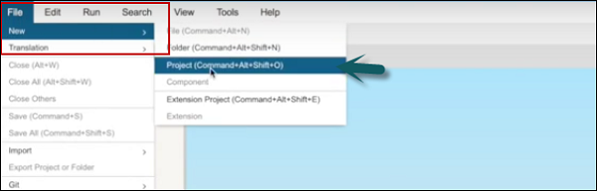
Step 2 − Enter the name of the project. In the next window, select the template.
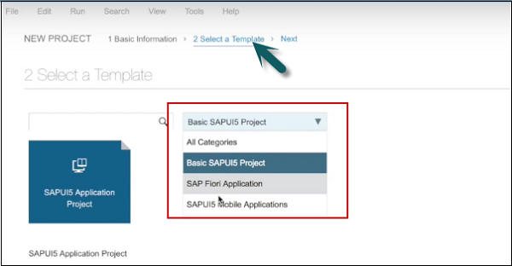
Step 3 − Select template SAPUI5 Mobile Applications → Next
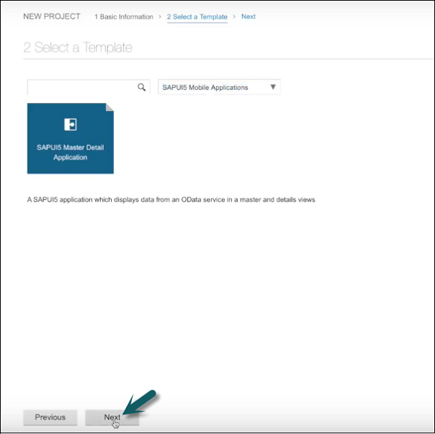
Step 4 − The next step is to select the data connection. Select service URL → Select
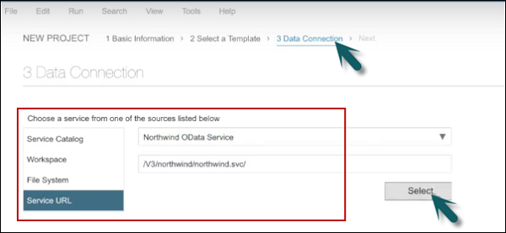
Step 5 − In the next step, you have to perform template customization.
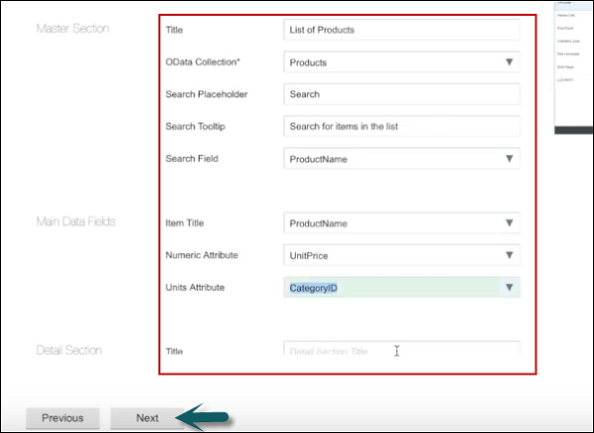
Step 6 − On clicking Next, you will see the Finish button.
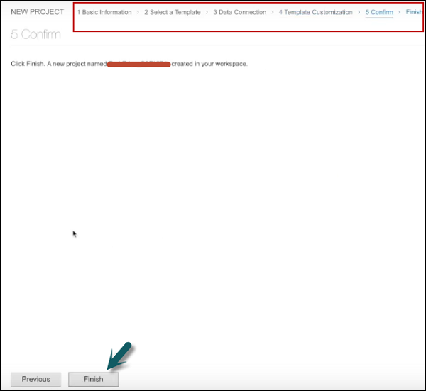
Once you click Finish, you can see a new project created that has default structure of UI application. It contains the view, model, and name of the project.
